**1. Create the following vectors in R.**

**a = (5, 10, 15, 20, ..., 160) b = (152, 153, 154, 155, ...,7)**

**Use vector arithmetic to multiply these vectors and call the result ‘d’.**

**Select subsets of d to identify the following.**

**• What are the 19th, 20th, and 21st elements of d?**

12730 13300 13860

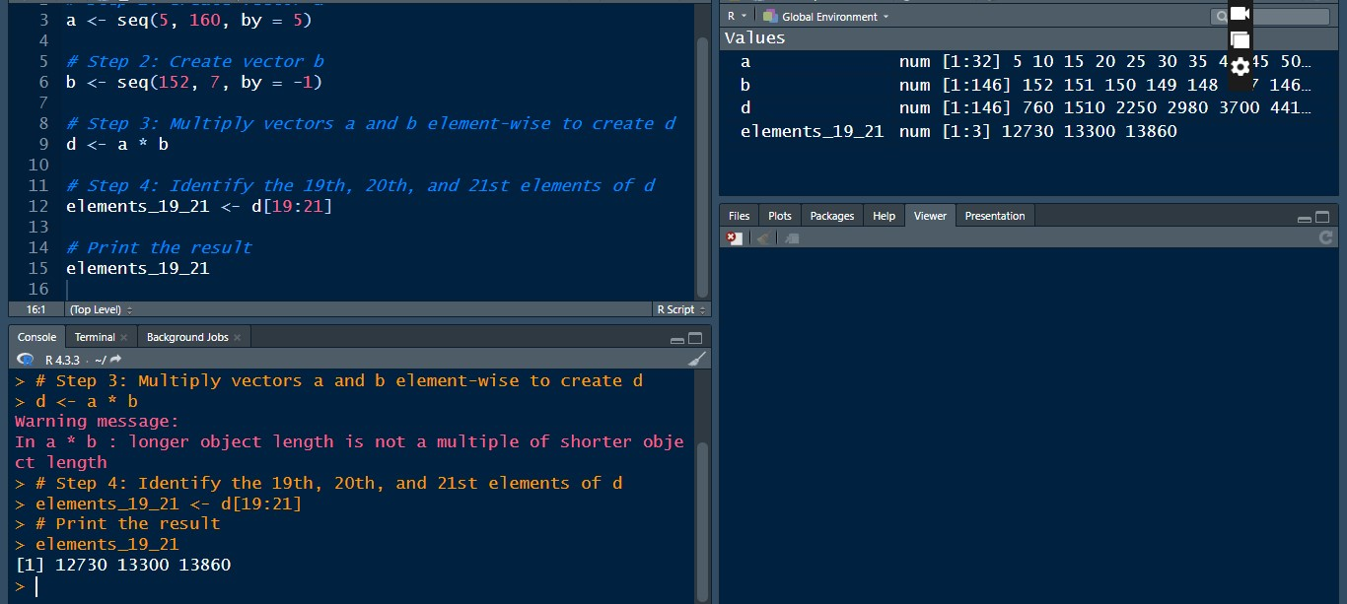

**What are all of the elements of d which are less than 2000?**

760 1510 600 1190 1770 440 870 1290 1700 280 550

810 1060 1300 1530 1750 1960 120 230 330 420 500

570 630 680 720 750 770 780 780 770 750 720

680 630

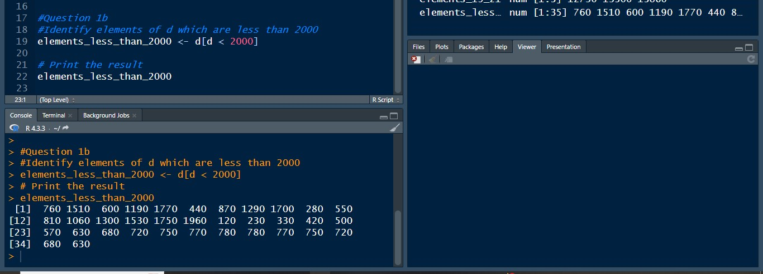

**• How many elements of d are greater than 6000?**

62

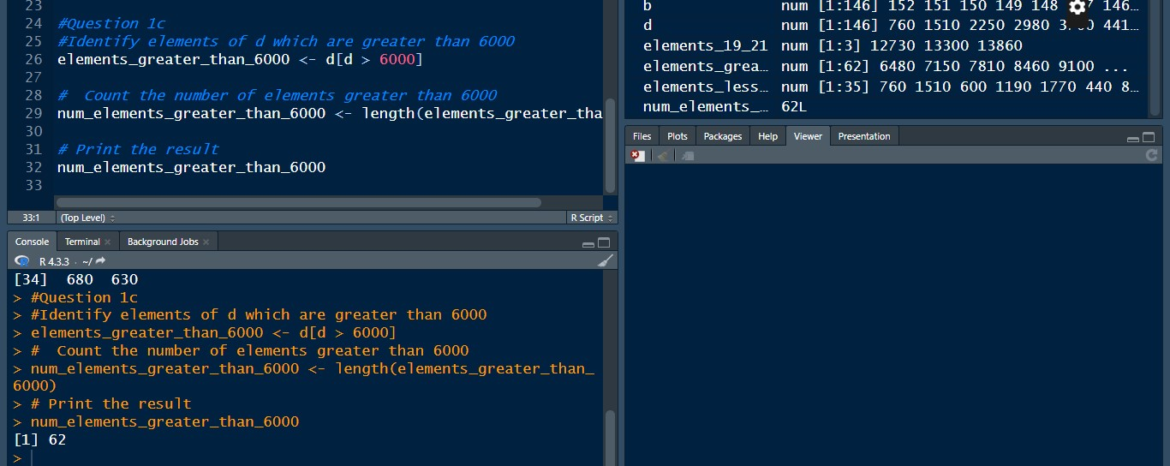

**2. Create a vector with some of your friend’s names**

**• Get the first two friends from above vector**

**• Sort your friends by names using 2 methods**

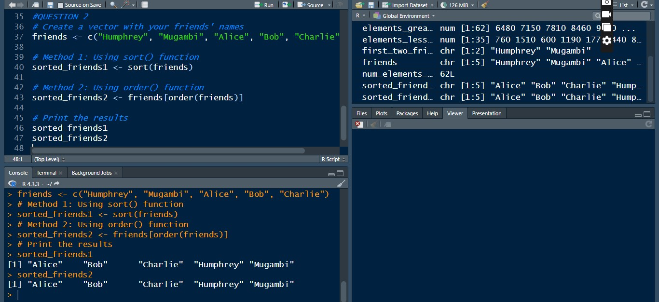

**3. Create three vectors x,y,z with integers and each vector has 3 elements.**

**Combine the three vectors to become a 3×3 matrix A where each column**

**represents a vector.**

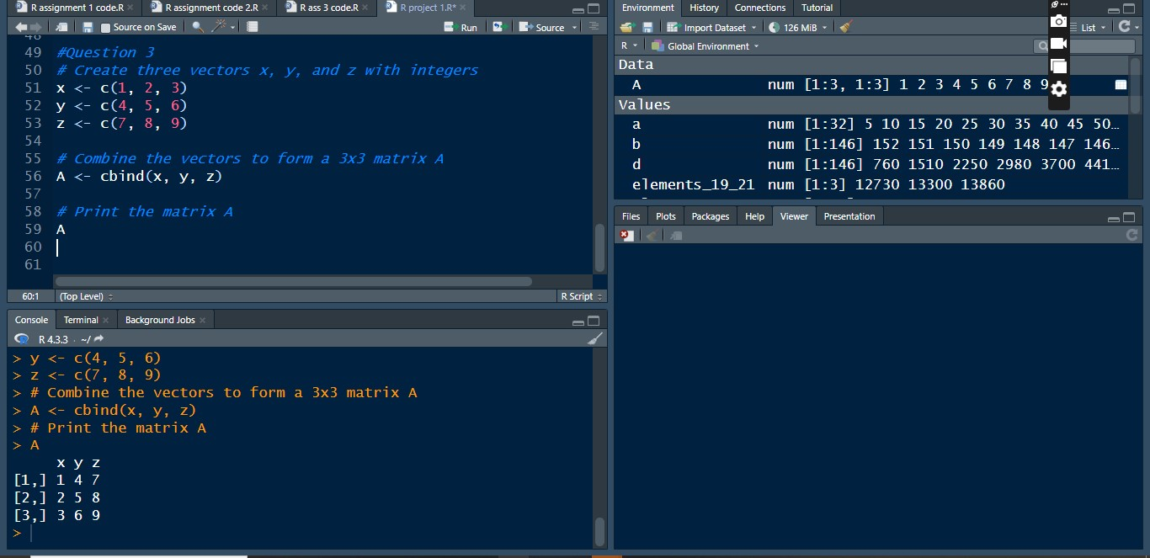

**4. Make a script file which constructs three random normal vectors of length**

**100. Call these vectors x1, x2 and x3. Make a data frame called t with three**

**Columns**

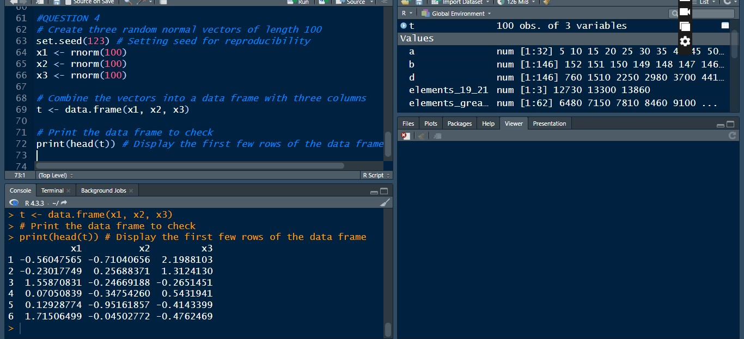

**5. Use the ‘arthritis’ data frame, to get the summary and the top 6 rows**

